Cook Library Database System – Tutorial Manual

1. Introduction
This User Guide provides an overview of the Cook Library Database System, including how to navigate the system, manage books and members, process loans and reservations, and understand system-generated reports.

2. Login Page
The Login Page is where users authenticate and access the Cook Library system. The current version uses a basic form that checks user credentials then makes them log into their SQL data base.
Figure 1: Login Page Screenshot
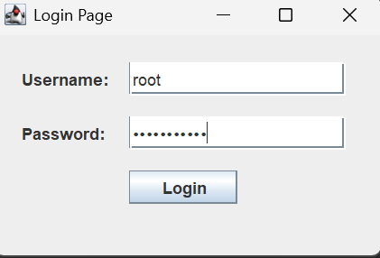
Figure 2: Login to SQL
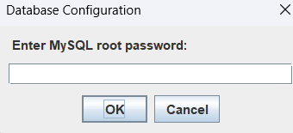

3. Books Module
This module displays all books in the system and allows staff to add, update, or remove book records.

3.1 View Books Table
The Books Table lists ISBN, title, author, genre, and availability status. Search and filtering are available for quick navigation.
Figure 3: Books Table Screenshot
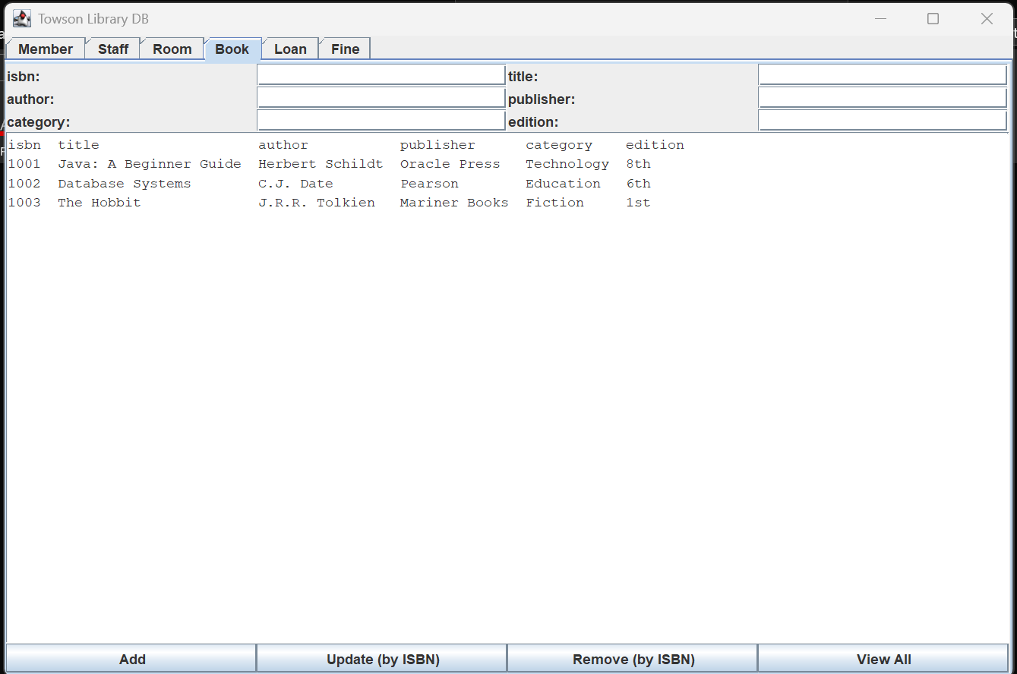

3.2 Add New Book
The Add New Book form allows staff to input a new book's ISBN, title, author, publication year, and genre. The system automatically links the book to generated book copies.
Figure 4: Add New Book Form
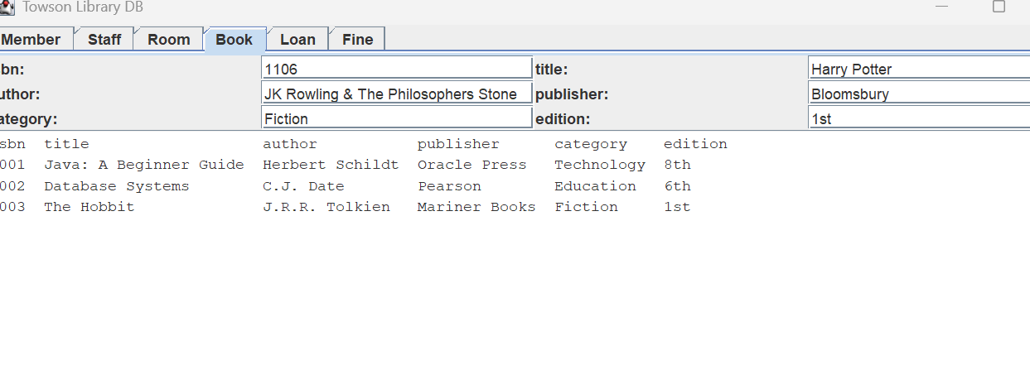
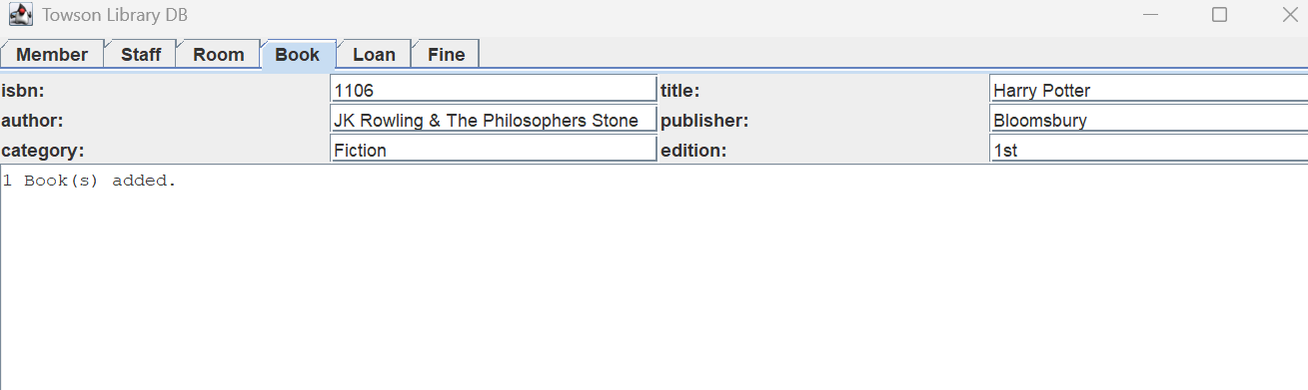
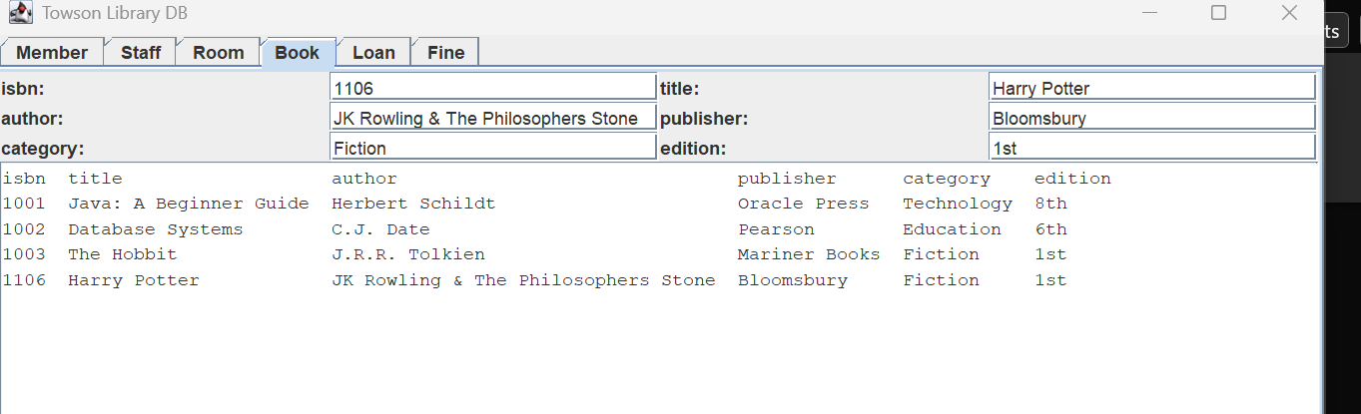

4. Members Module
Displays all registered library members, including basic contact information and membership type.
Figure 5: Members tab displaying everything
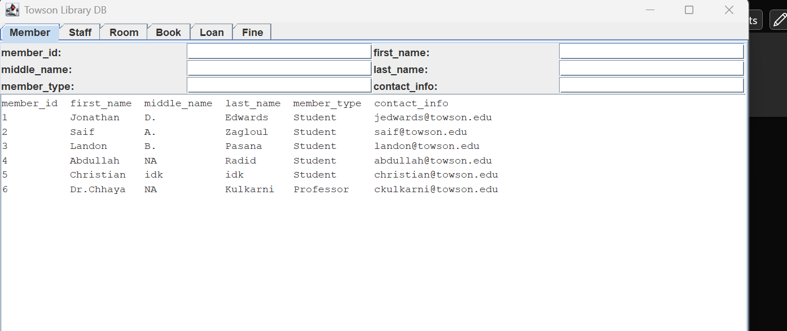

4.1 Add New Member
This form is used to register new members. Required fields include first name, middle name, last name, email, and membership type, and contact information.
Figure 6: Add Member Form
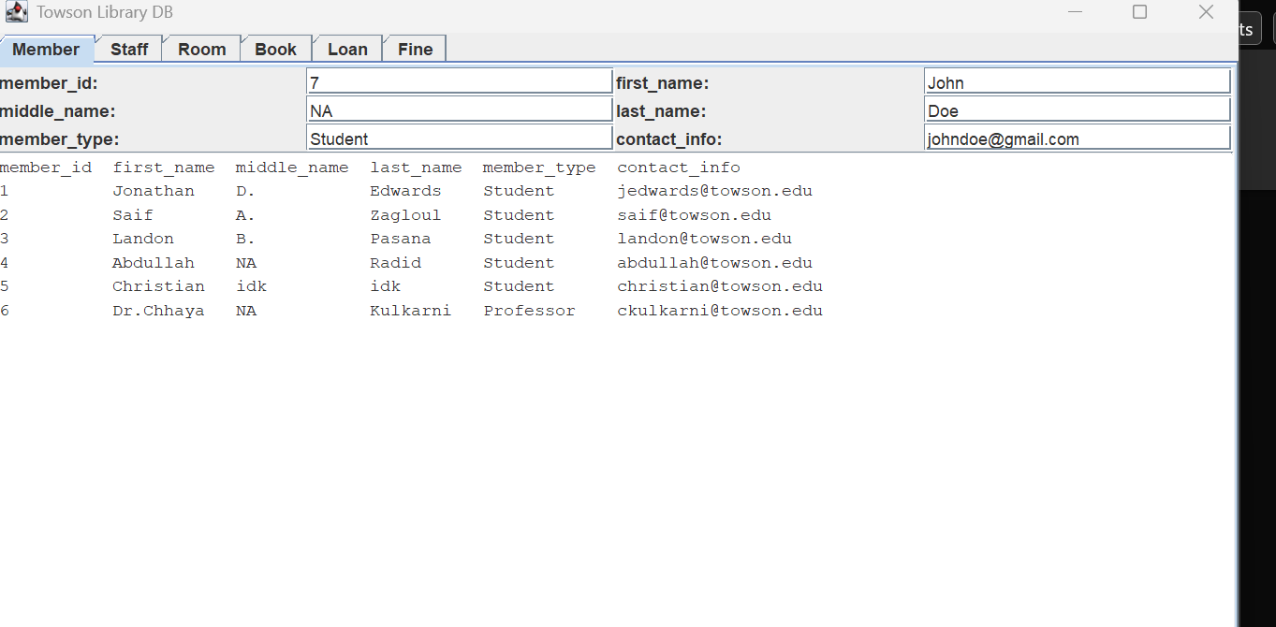
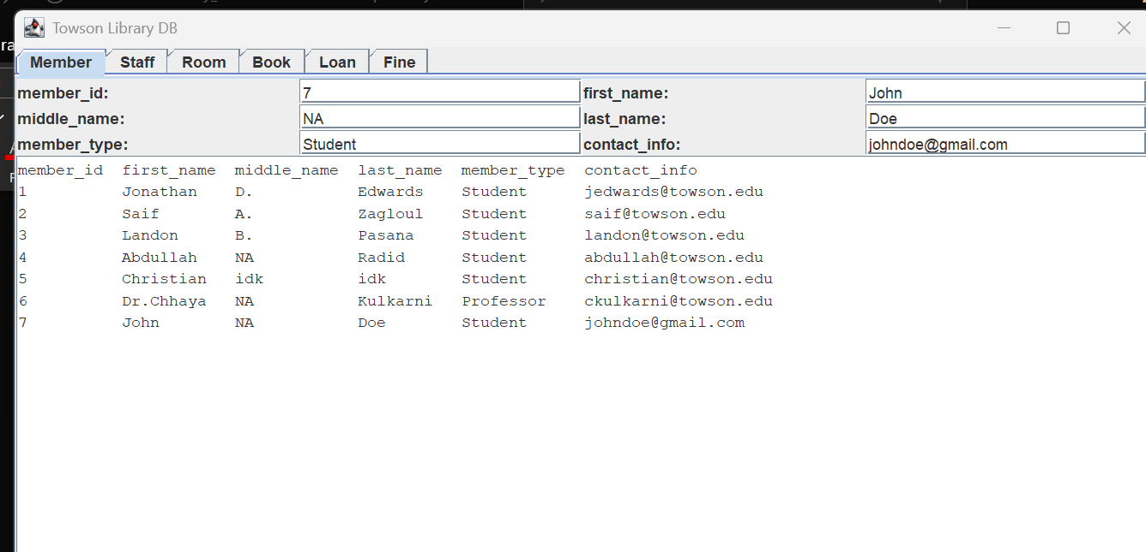

5. Loans (Borrowing System)
The Loans screen allows staff to issue books, return books, and view borrowing history.
Figure 7: Loan Management Screen
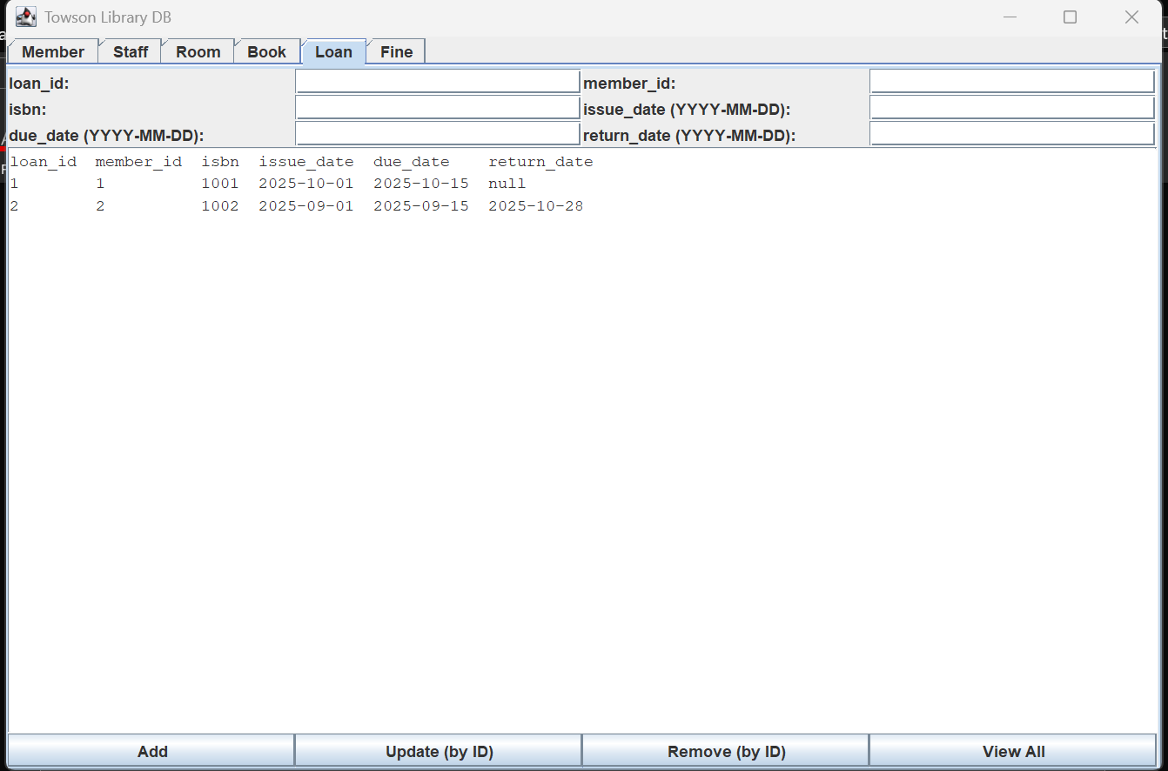

6. Fines
The Fines module shows all members fines and you can manually take them out by ID
Figure 8: Fines Screen
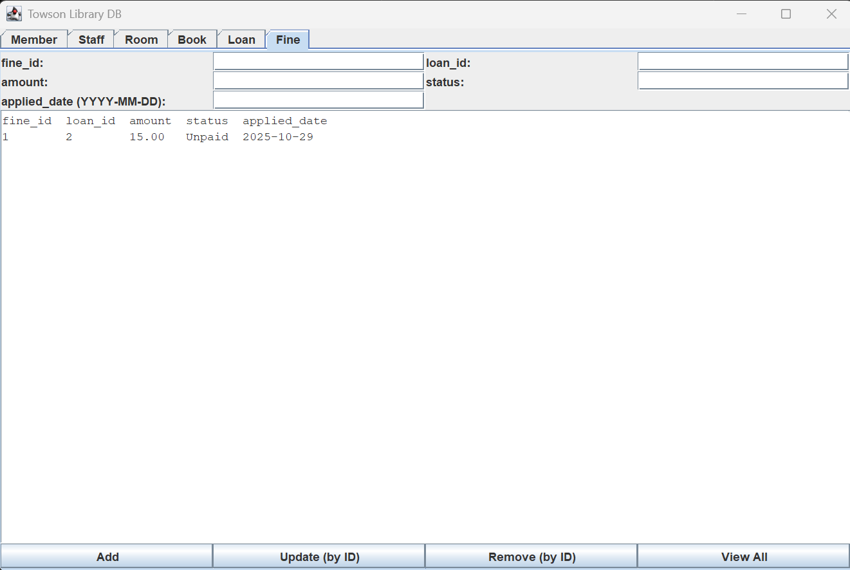

7. Room
The room module displays the room id, room name, and capacity of that room.
Figure 9:
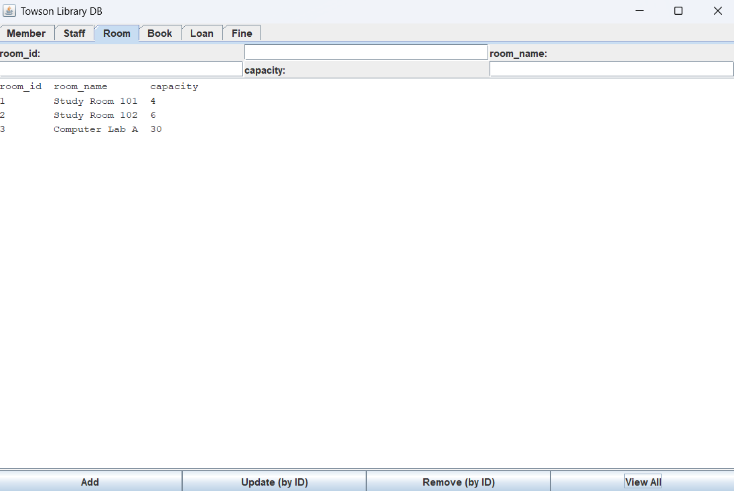

8. Staff
The staff module shows the staff id, first name, last name, and contact info. You can also update and delete it by id at the bottom of the screen.
Figure 10:
